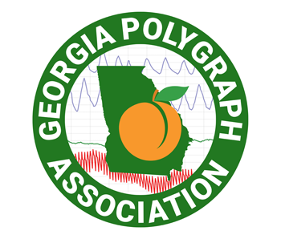

2021 Tri-State Polygraph Conference Registration
September 29, 30, October 1, 2021  20 hours of: | Hotel Tybee Conference Facility  1401 Stand Avenue, Tybee Island, GA 31328
- APA advanced/specialized training  - POST credit for Georgia law enforcement officers with  O-Key Number: | Lodging at Hotel Tybee:  - Use the promotion code GPA2021 for conference rate  - Register at www.hoteltybee.com or call 912-786-7777  - They will accept your tax exemption form

 | Polygraph Examiner: |  |  |  |  | Professional Affiliation:  GPA ___  NCPA ___  SCAPE ___  Private ___  Other ___
 | Agency / Employer:
 | E-Mail Address:
 | Phone:
Deadline for registration: August 1, 2021
Seating may be limited as determined by any pandemic restrictions, so early registration is encouraged
 | Registration fee: $100.00  $125.00 | Waived for GPA members in good standing (2021 dues paid)  Non-GPA members paid prior to August 1, 2021  Non-GPA members paid after August 1, 2021
 | Any cancellation received in writing prior to September 1, 2021, will receive a full refund
Comments / Questions: |  |  |  | Registration / Payment Options:
 |  |  |  | Email registration to: | gpassoc1998@gmail.com
 |  |  |  | PayPal payment to: | gpassoc1998@gmail.com  select “personal payment” to avoid service charges
 |  |  |  | Mail registration form  and payment to: | Don Berecz (GPA Treasurer)  P.O. Box 2992  Statesboro, GA 30459  Phone: (912) 536-5198

