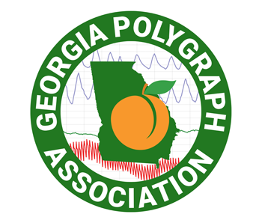

Georgia Bureau of Investigation / Georgia Polygraph Association
2022 Polygraph Conference
September 12 - 14, 2022
20 CPE hours of:  APA advanced / specialized training  POST credit for Georgia law enforcement officers with O-Key # | Marriott Savannah Riverfront  100 General McIntosh Blvd, Savannah, GA 31401  Reservations can be made with the Group Code  2022 GBI/GPA Poly Conference by calling 800-285-0398 or use this link: Book your group rate for 2022 GBI/GPA Polygraph Conference  Tax exemption forms must be provided at time of check in
Polygraph Examiner:

Agency / Employer:

E-Mail Address:

Phone: |  |  | Check One
Deadline for registration:  August 1, 2022 |  | GPA members in good standing  (2022 dues paid): No registration fee
 |  | All other polygraph examiners: $150.00
Email or mail registration form  and / or payment to: |  | Don Berecz (GPA Treasurer)  P.O. Box 2992  Statesboro, GA 30459  Phone: (912) 536-5198  gpassoc1998@gmail.com
PayPal payment to:
gpassoc1998@gmail.com

